**Lab#10:**

Objective:To implement preserving user state in distributed applications.

1.Create a simple Login Logout and Profile page and use cookie to preserve user state but use MVC Architecture.

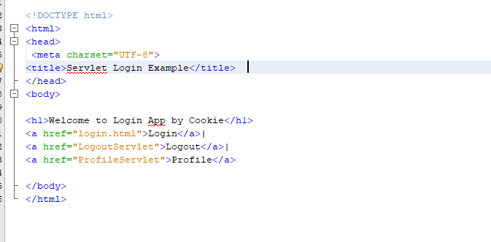

Login

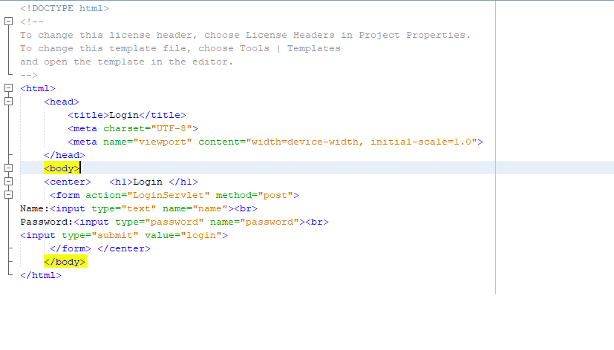

Logout Servelet

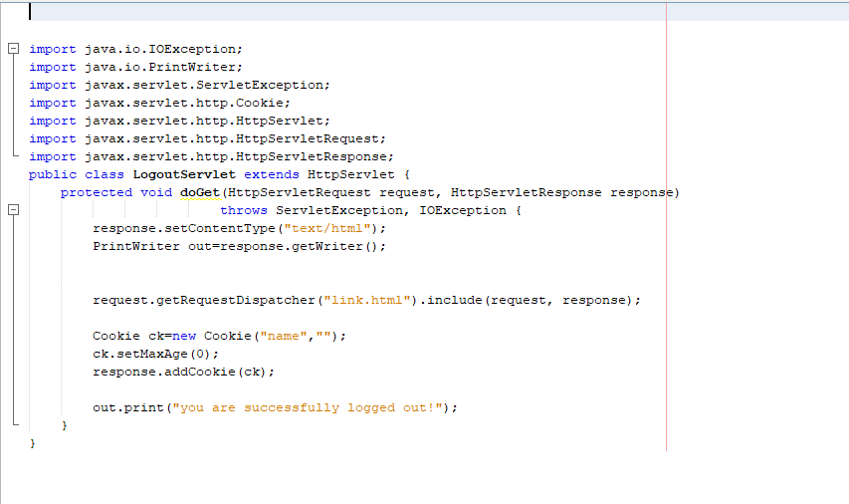

**Output:**



